Олимпиада по английскому языку 5 класс

Рекомендуемое время выполнения заданий – 45 минут.

1. Put the words in the alphabetical order.
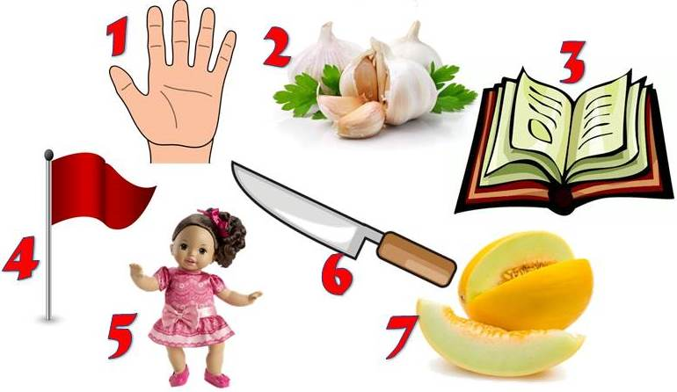
А) 1, 2, 4, 3, 6, 5, 7 Б) 3, 5, 4, 2, 1, 6, 7
В) 3, 4, 5, 1, 2, 6, 7 Г) 7, 6, 1, 2, 4, 3, 5

2. Fill in the table paying attention to the pronunciation of the endings.
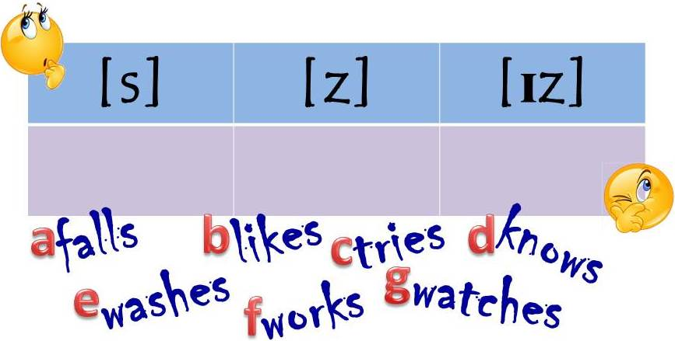
А) [s]: b, f; [z]: a, c, d; [ɪz]: e, g
Б) [s]: e, g; [z]: a, c, d; [ɪz]: b, f
В) [s]: a, f, c; [z]: b, d; [ɪz]: e, g
Г) [s]: b, g; [z]: a, c, e; [ɪz]: d, f

3. Put the words in the right order.
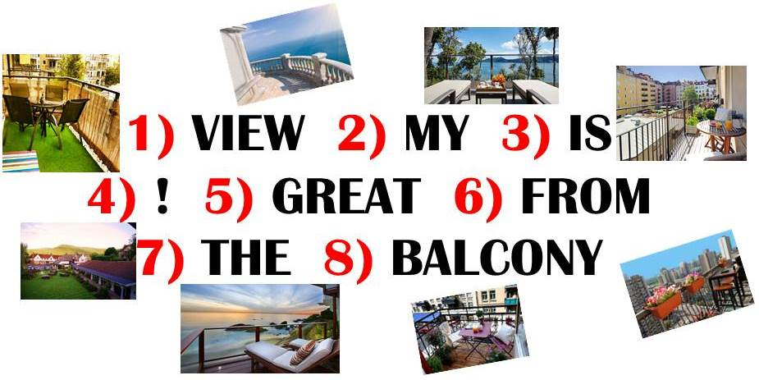
А) 7, 1, 6, 2, 8, 3, 5, 4 Б) 2, 8, 7, 1, 6, 3, 5, 4
В) 7, 8, 5, 6, 2, 1, 3, 4 Г) 2, 1, 6, 7, 8, 3, 5, 4

4. Fill in the gaps with the right question words.
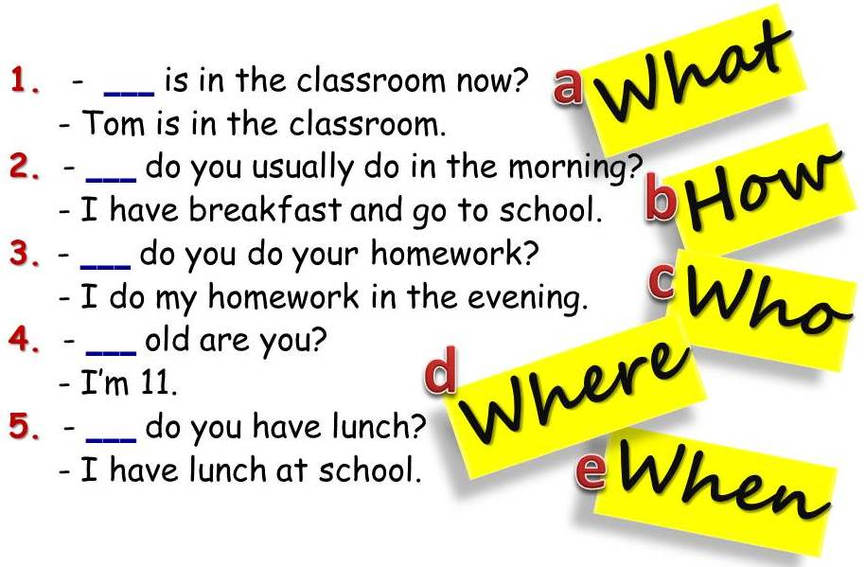
А) 1e, 2b, 3c, 4a, 5d Б) 1c, 2e, 3a, 4b, 5d
В) 1c, 2a, 3e, 4d, 5b Г) 1c, 2a, 3e, 4b, 5d

5. Choose the right variant.
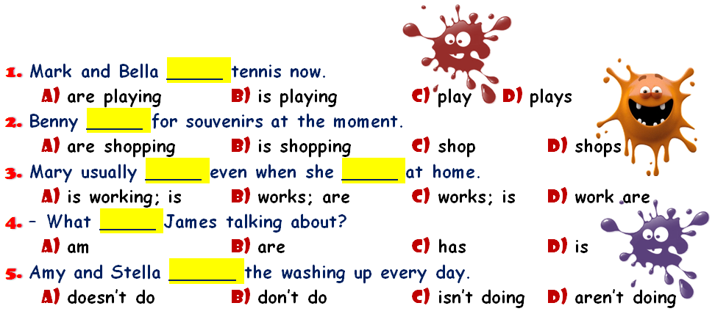
А) 1 A, 2 B, 3 A, 4 D, 5 A Б) 1 C, 2 D, 3 C, 4 D, 5 B
В) 1 A, 2 B, 3 C, 4 D, 5 B Г) 1 A, 2 B, 3 C, 4 B, 5 D

6. Look at Mark’s family tree and complete the sentences.
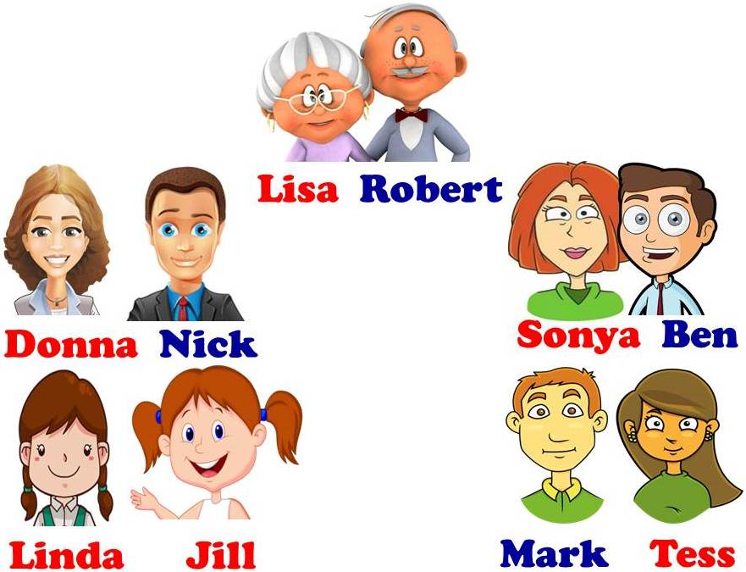
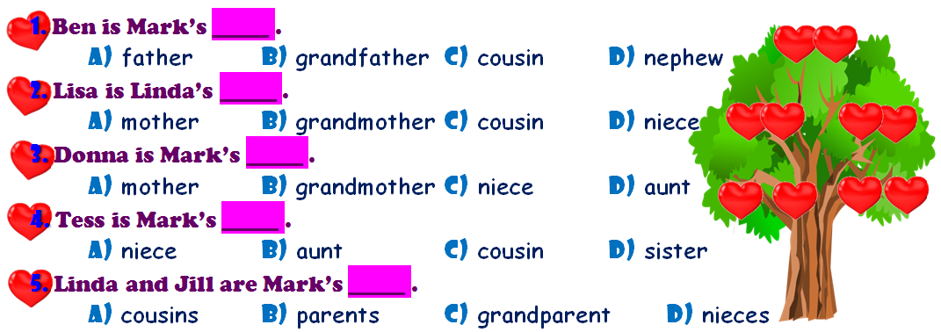
А) 1 A, 2 B, 3 D, 4 D, 5 D Б) 1 A, 2 B, 3 D, 4 D, 5 A
В) 1 C, 2 A, 3 D, 4 D, 5 A Г) 1 B, 2 C, 3 D, 4 D, 5 A

7. Read the text and mark the following sentences as true or false.
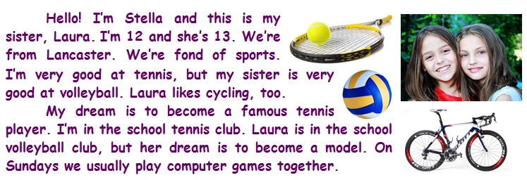
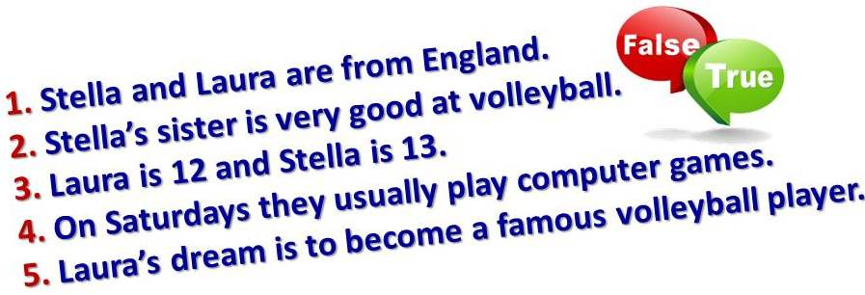
А) 1 false, 2 true, 3 true, 4 false, 5 false
Б) 1 true, 2 true, 3 false, 4 false, 5 false
В) 1 true, 2 true, 3 true, 4 true, 5 false
Г) 1 true, 2 true, 3 true, 4 false, 5 true

8. Fill in at, in or on.
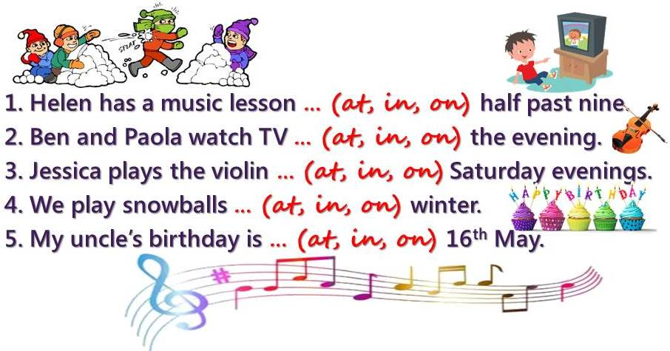
А) 1 at, 2 in, 3 on, 4 in, 5 on Б) 1 on, 2 in, 3 in, 4 in, 5 on
В) 1 in, 2 in, 3 on, 4 at, 5 on Г) 1 at, 2 on, 3 in, 4 in, 5 in

9. Solve the puzzle.
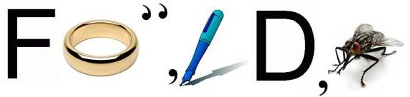
А) friendly Б) folder В) fondly Г) freedom

10. Do the crossword. Make up a key word using circled letters.
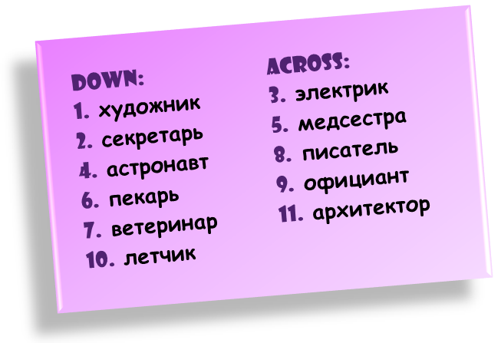
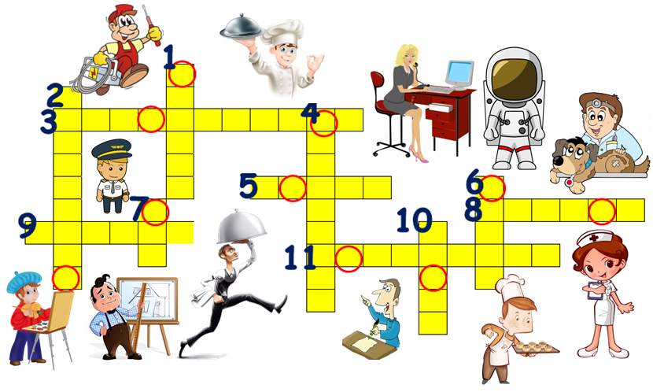
А) strawberry Б) basketball В) volleyball Г) vocabulary

