Олимпиада по английскому языку 6 класс

Рекомендуемое время выполнения заданий – 45 минут.

1. Match holidays to the dates.
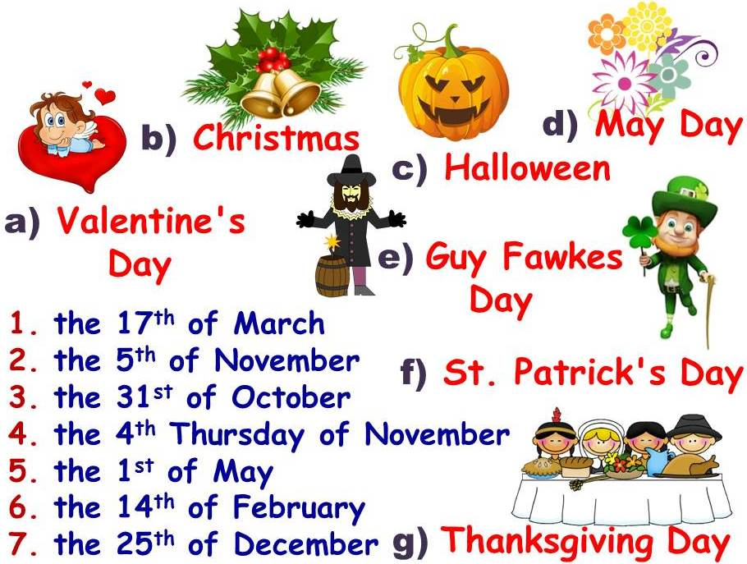
А) 1f, 2e, 3b, 4d, 5g, 6a, 7c Б) 1f, 2e, 3g, 4c, 5d, 6a, 7b
В) 1e, 2f, 3c, 4g, 5d, 6a, 7b Г) 1f, 2e, 3c, 4g, 5d, 6a, 7b

2. Divide the following words into three groups according to their pronunciation.
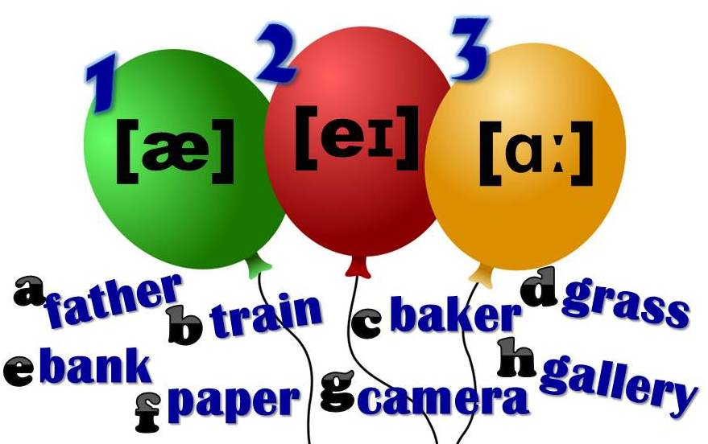
А) [æ]: e, g, h; [eɪ]: b, c, f; [ɑː]: d, a Б) [æ]: g, h; [eɪ]: b, a, f; [ɑː]: d, c, e
В) [æ]: e; [eɪ]: b, c, f, g; [ɑː]: d, a, h Г) [æ]: b, c, f, g, h; [eɪ]: e, g, h; [ɑː]: d, a

3. Put the words in the correct order.
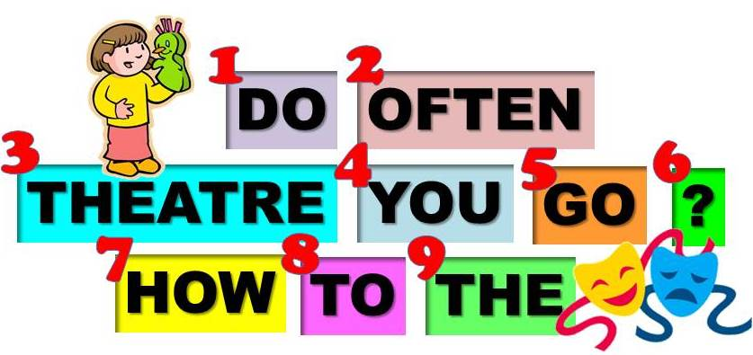
А) 2, 7, 1, 4, 8, 5, 9, 3, 6 Б) 7, 2, 4, 1, 5, 8, 9, 3, 6
В) 7, 1, 4, 5, 8, 9, 3, 2, 6 Г) 7, 2, 1, 4, 5, 8, 9, 3, 6

4. Make up correct word combinations with the words “make” and “do”.
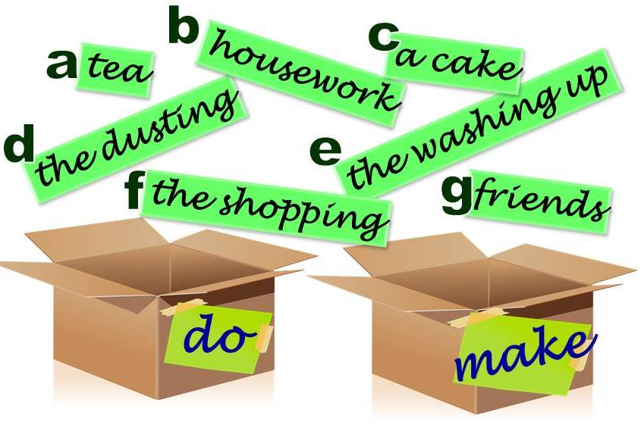
А) do: a, c, g; make: b, d, e, f Б) do: b, d, e, f; make: a, c, g
В) do: b, d, e; make: a, c, f, g Г) do: a, b, d, e, f; make: c, g
5. Choose the correct sentences.
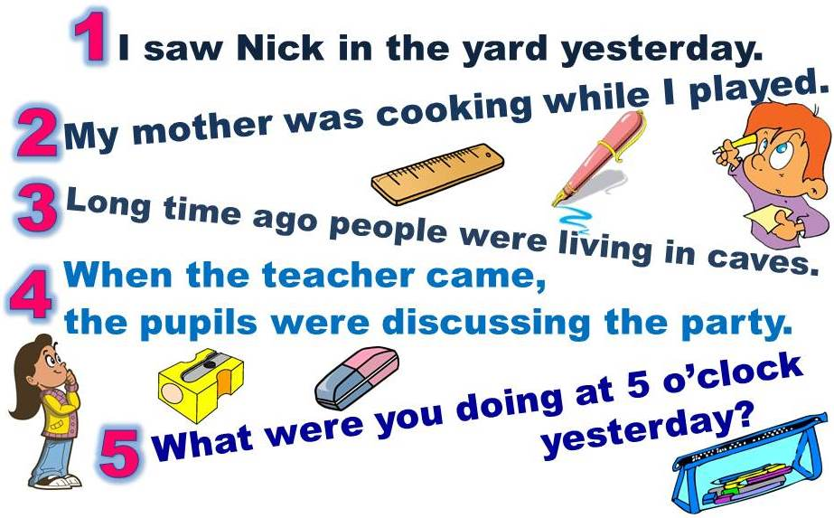
А) 1, 4, 5 Б) 2, 3 В) 1, 3, 5 Г) 1, 4

6. Fill in correct prepositions.
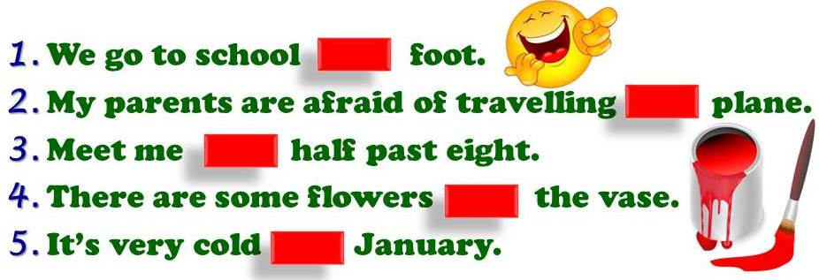
А) 1 by, 2 by, 3 at, 4 in, 5 on Б) 1 on, 2 by, 3 at, 4 on, 5 in
В) 1 on, 2 by, 3 at, 4 in, 5 in Г) 1 on, 2 on, 3 at, 4 in, 5 in

7. Use -er, -ist, -or to make nouns.
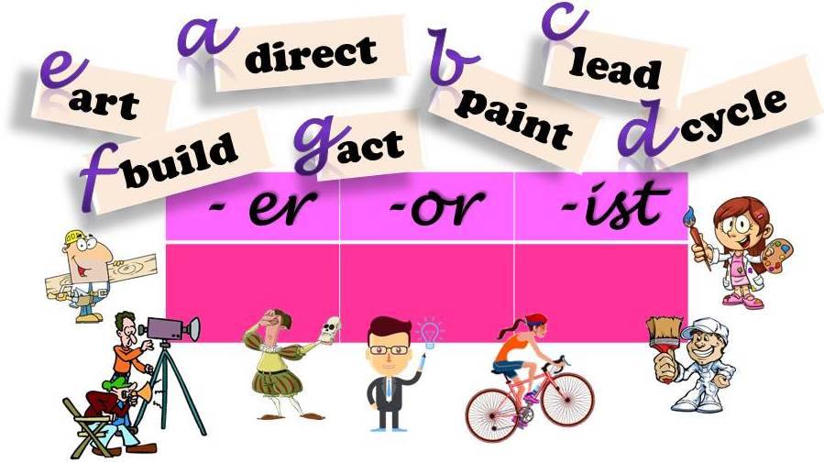
А) -er; a, g; -or: b, c, f; -ist: d, e Б) -er; b, c, f; -or: d, e; -ist: a, g
В) -er; c, f; -or: a, b, g; -ist: d, e Г) -er; b, c, f; -or: a, g; -ist: d, e

8. Read the texts and mark the sentences as true or false.
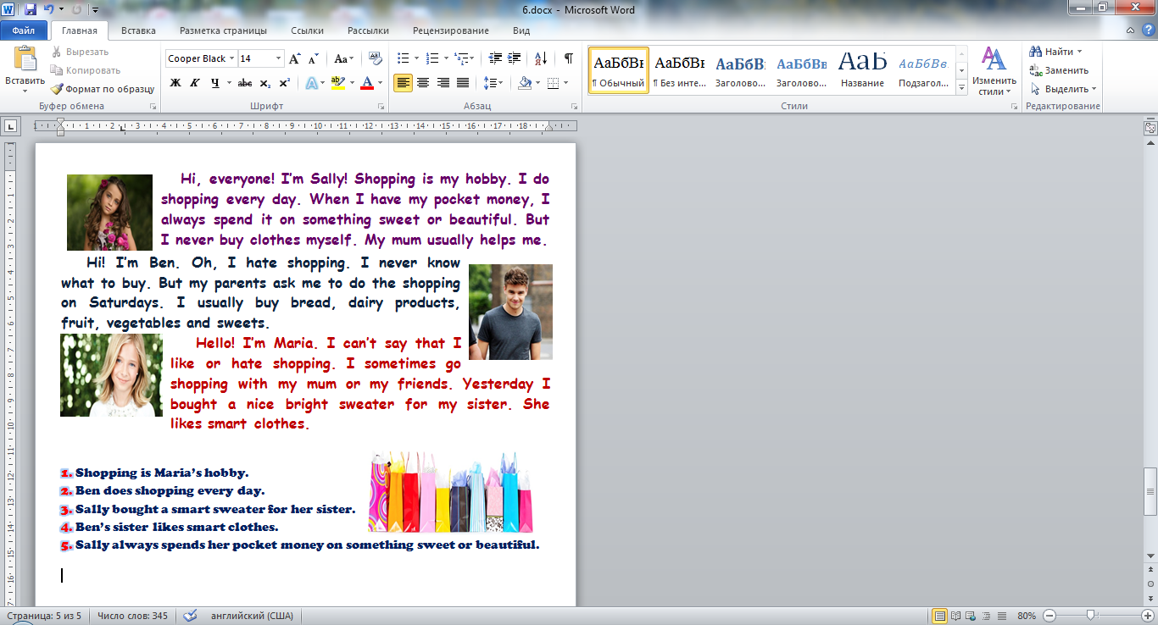
А) 1 false, 2 false, 3, false, 4 false, 5 true
Б) 1 false, 2 false, 3, true, 4 true, 5 true
В) 1 false, 2 true, 3, false, 4 false, 5 false
Г) 1 true, 2 true, 3, false, 4 false, 5 true

9. Solve the rebus.
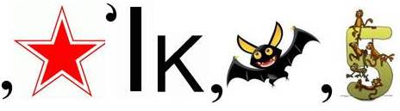
А) talkative Б) bulkhead В) chalkstone Г) talkies

10. Look at the pictures. Find 14 words in the word search. Make up a key word from the left letters.
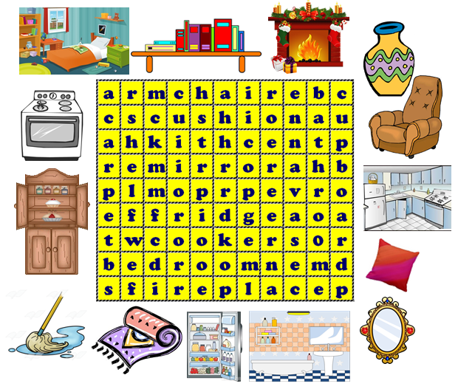
А) vegetable Б) challenge
В) knowledge Г) newspaper

