Олимпиада по английскому языку 7 класс

Рекомендуемое время выполнения заданий – 45 минут.

1. Match English and Russian equivalents.
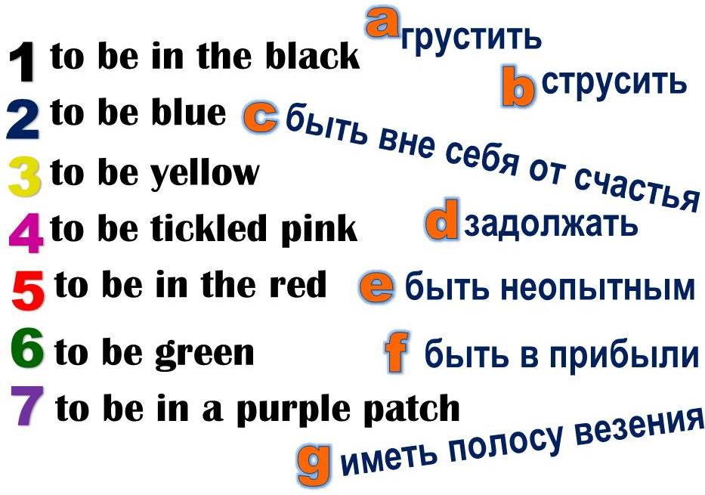
А) 1f, 2a, 3c, 4b, 5g, 6e, 7d Б) 1f, 2a, 3b, 4c, 5d, 6e, 7g
В) 1d, 2a, 3b, 4c, 5f, 6e, 7g Г) 1a, 2f, 3c, 4b, 5d, 6e, 7g

2. Choose the right item.
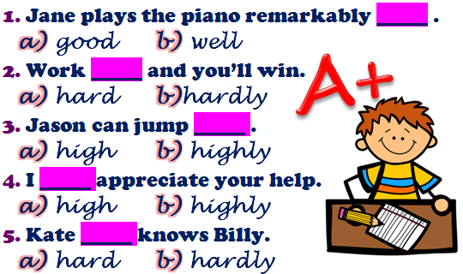
А) 1a, 2a, 3b, 4b, 5a Б) 1a, 2b, 3b, 4b, 5b
В) 1b, 2a, 3a, 4a, 5a Г) 1b, 2a, 3a, 4b, 5b

3. Fill in the gaps with articles where necessary to complete the text.
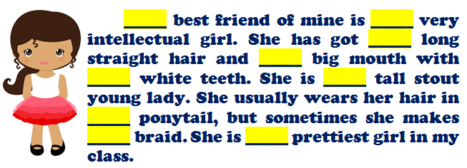
А) the, a, –, a, –, a, a, a, the Б) the, a, the, a, –, a, –, the, the
В) –, a, а, a, –, a, the, –, – Г) the, the, a, a, –, –, a, –, the

4. Fill in the gaps with the correct postpositions.
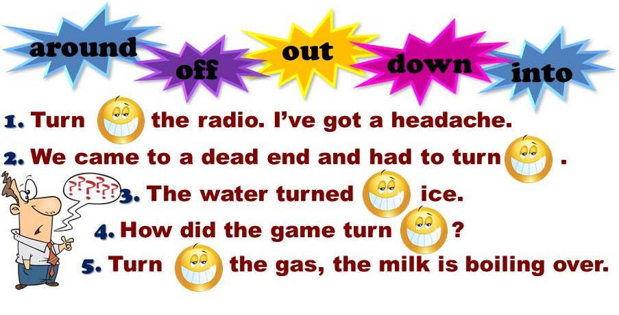
А) 1 down, 2 around, 3 into, 4 off, 5 out Б) 1 down, 2 around, 3 into, 4 out, 5 off
В) 1 around, 2 down, 3 into, 4 out, 5 off Г) 1 down, 2 around, 3 out, 4 into, 5 off

5. Match the columns to make the phrases correct.
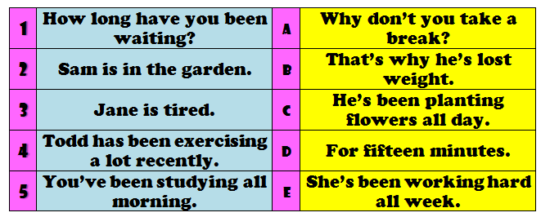
А) 1a, 2b, 3c, 4e, 5d Б) 1d, 2c, 3e, 4b, 5a
В) 1b, 2a, 3d, 4c, 5e Г) 1c, 2b, 3a, 4d, 5e

6. Choose the correct sentences.
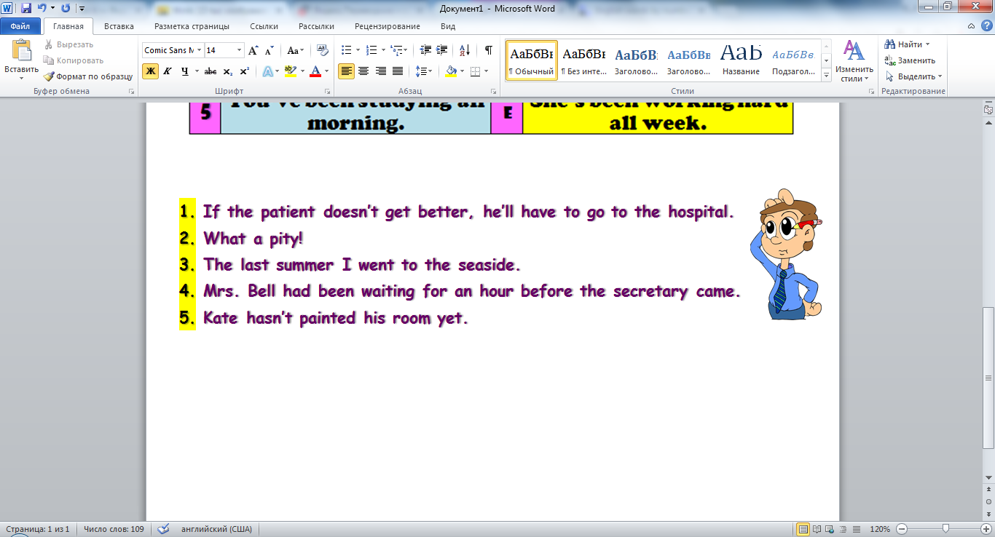
А) 2, 1, 3 Б) 4, 5 В) 2, 5 Г) 2, 4, 5

7. Complete the text with the following words.
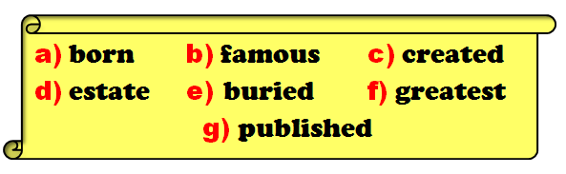
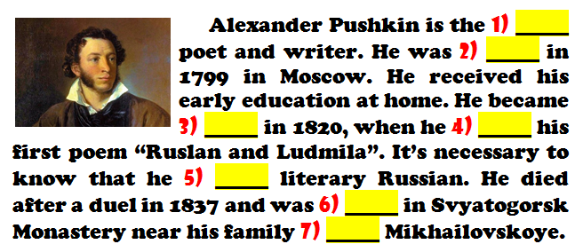
А) 1f, 2a, 3b, 4g, 5c, 6e, 7d Б) 1f, 2d, 3b, 4g, 5e, 6c, 7a
В) 1f, 2b, 3a, 4g, 5c, 6d, 7e Г) 1b, 2a, 3f, 4g, 5c, 6e, 7d

8. Solve the riddles.
1) 
2) 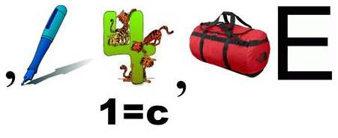
А) 1) badminton; 2) encourage Б) 1) baboon; 2) divergence
В) 1) brighten; 2) encourage Г) 1) brighten; 2) avoidable

9. Translate the following words and find out the hidden one.
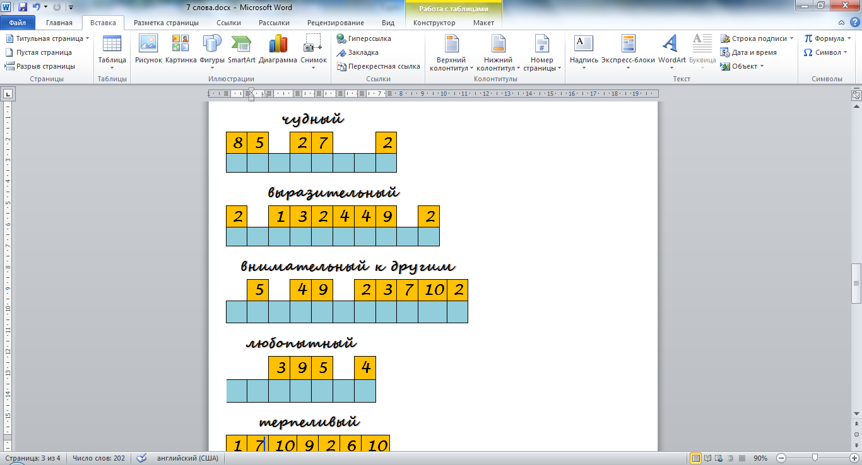
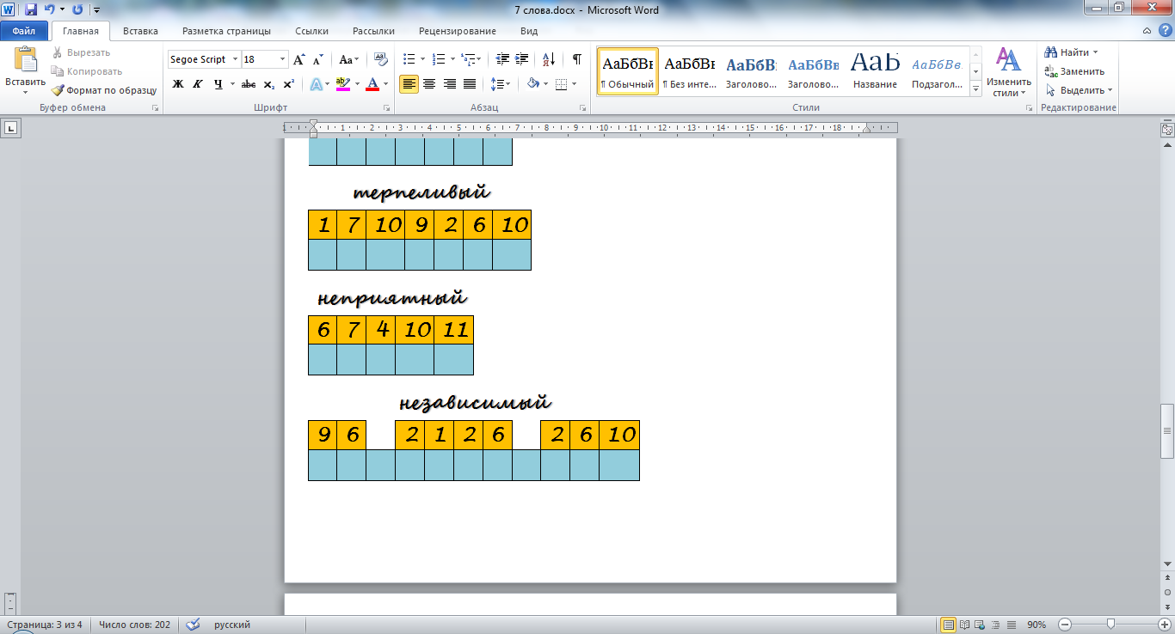
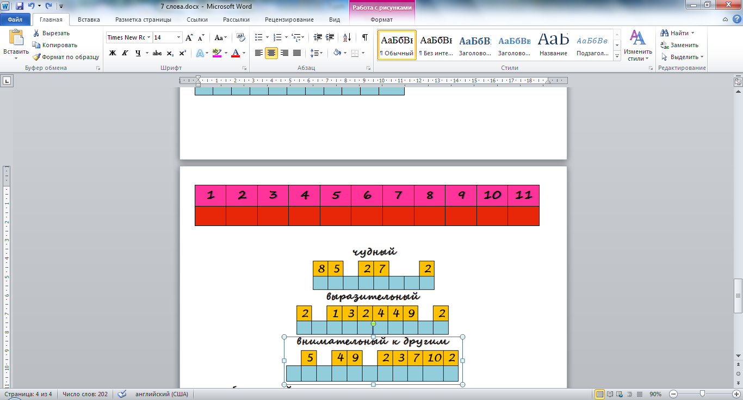
А) personality Б) information
В) preposition Г) celebration

10. Match the national parks with their descriptions.
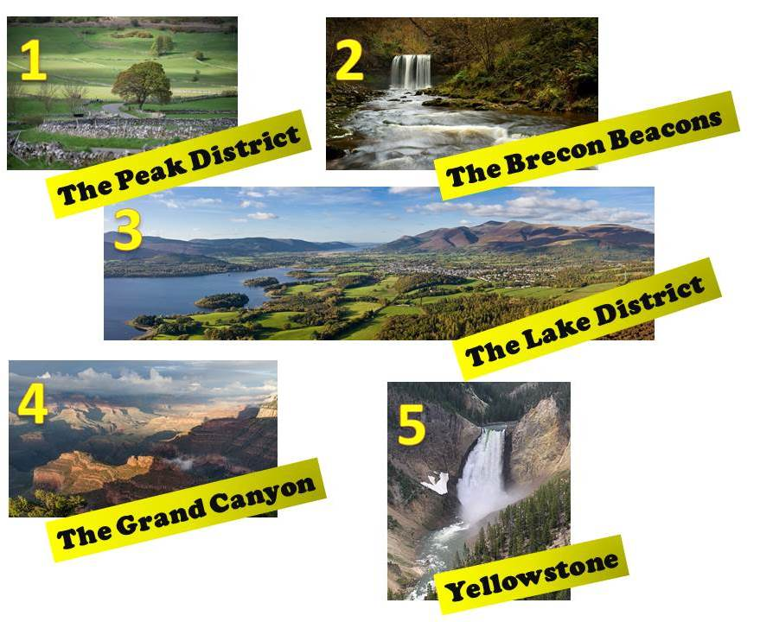
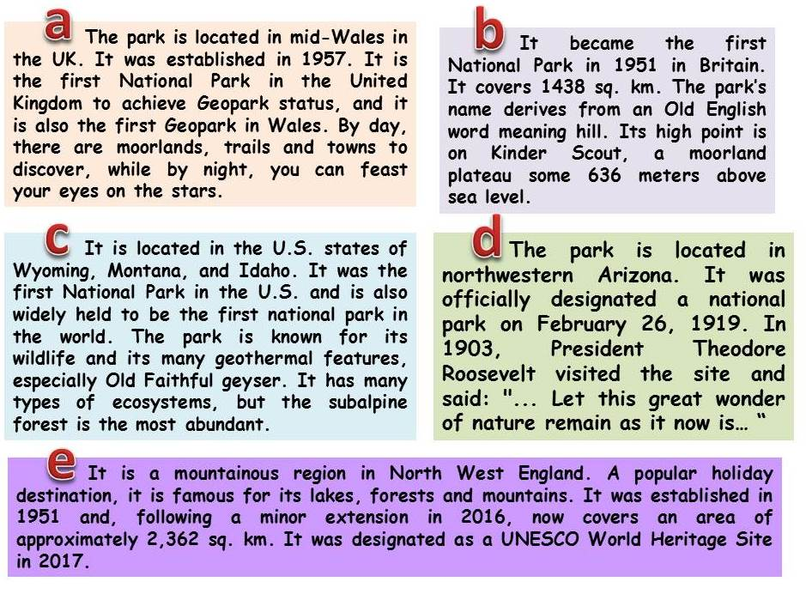
А) 1c, 2e, 3a, 4d, 5b Б) 1b, 2a, 3d, 4e, 5c
В) 1b, 2a, 3e, 4d, 5c Г) 1a, 2b, 3e, 4d, 5c

