Олимпиада по английскому языку 8 класс

Рекомендуемое время выполнения заданий – 45 минут.

1. Find a mistake in one of the underlined fragments.
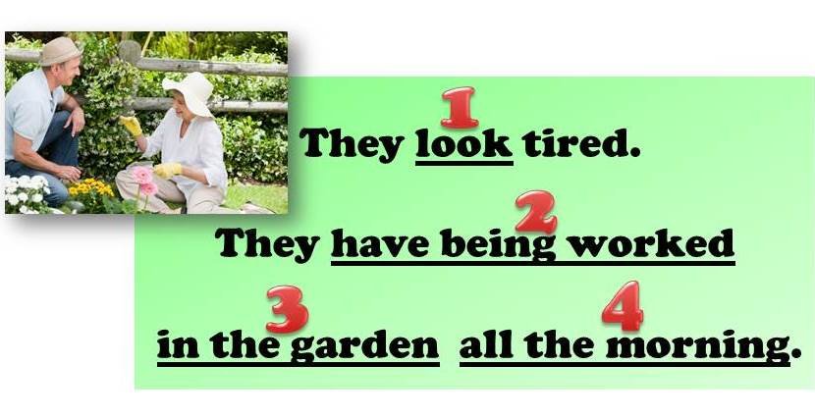
А) 1 Б) 2 В) 3 Г) 4

2. Make up a sentence from the given words.
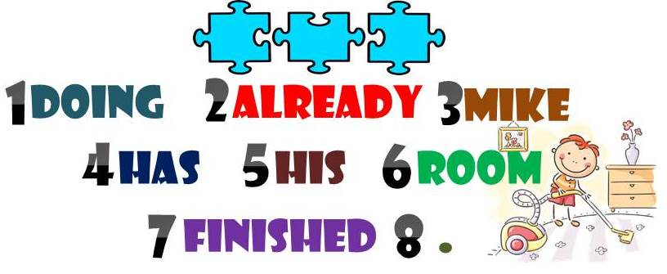
А) 3, 4, 7, 2, 5, 1, 6, 8 Б) 4, 3, 2, 7, 5, 1, 6, 8
В) 3, 4, 7, 2, 1, 6, 5, 8 Г) 3, 4, 2, 7, 1, 5, 6, 8

3. Match the following names of flowers with their pictures.
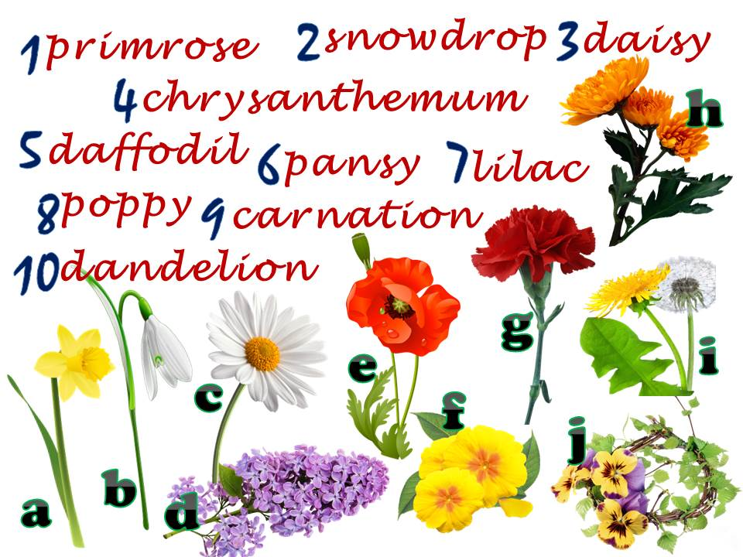
А) 1f, 2b, 3c, 4h, 5j, 6a, 7e, 8d, 9g, 10i Б) 1f, 2b, 3j, 4h, 5a, 6c, 7d, 8e, 9i, 10g
В) 1f, 2b, 3c, 4h, 5a, 6j, 7d, 8e, 9g, 10i Г) 1b, 2f, 3c, 4a, 5h, 6j, 7d, 8e, 9i, 10g

4. You know that some things have different names in Britain and America. Find the British words among the following ones.
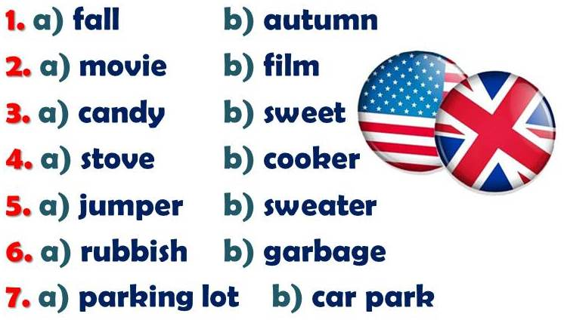
А) 1b, 2b, 3a, 4a, 5b, 6b, 7a Б) 1b, 2b, 3b, 4a, 5a, 6a, 7b
В) 1a, 2b, 3b, 4b, 5a, 6b, 7a Г) 1a, 2a, 3a, 4a, 5b, 6a, 7b

5. Make up correct word-combinations.
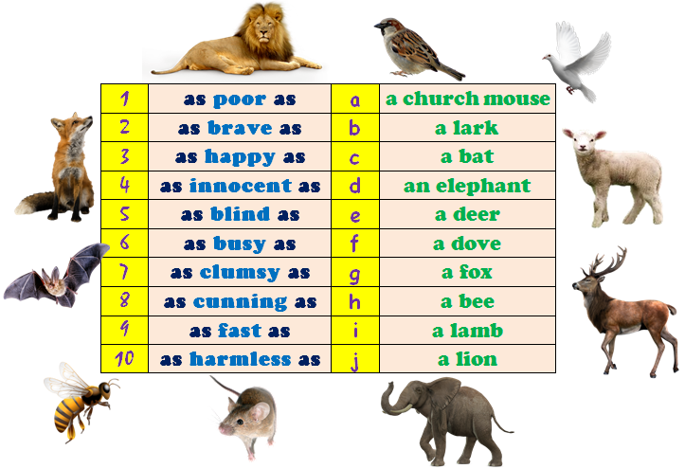
А) 1a, 2j, 3b, 4i, 5c, 6h, 7d, 8g, 9e, 10f Б) 1j, 2a, 3b, 4i, 5c, 6d, 7h, 8g, 9e, 10f
В) 1f, 2j, 3b, 4i, 5c, 6h, 7d, 8e, 9g, 10a Г) 1a, 2b, 3j, 4i, 5c, 6e, 7d, 8g, 9h, 10f

6. Choose the right variant.
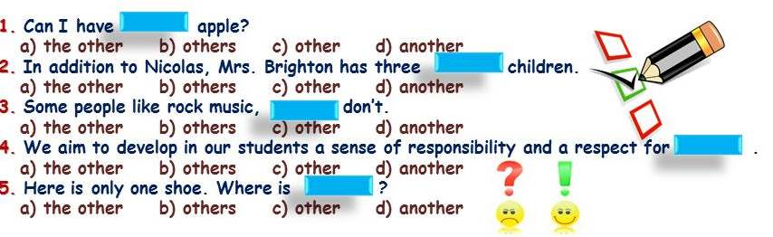
А) 1a, 2c, 3a, 4d, 5a Б) 1d, 2c, 3a, 4b, 5c
В) 1d, 2c, 3b, 4b, 5a Г) 1c, 2c, 3b, 4a, 5a

7. Fill in the gaps with articles where necessary to complete the text.
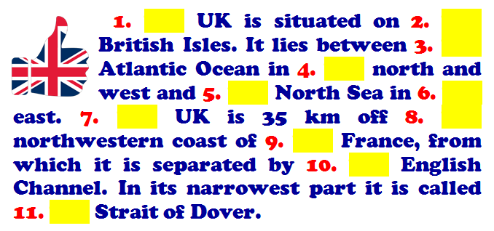
А) 1 –, 2 the, 3 –, 4 the, 5 the, 6 the, 7 –, 8 the, 9 –, 10 the, 11 –
Б) 1 –, 2 the, 3 the, 4 the, 5 the, 6 the, 7 –, 8 the, 9 –, 10 the, 11 –
В) 1 –, 2 the, 3 the, 4 the, 5 the, 6 the, 7 –, 8 the, 9 –, 10 the, 11 the
Г) 1 the, 2 the, 3 the, 4 the, 5 the, 6 the, 7 the, 8 the, 9 –, 10 the, 11 the

8. Choose the right variant and complete the sentences.
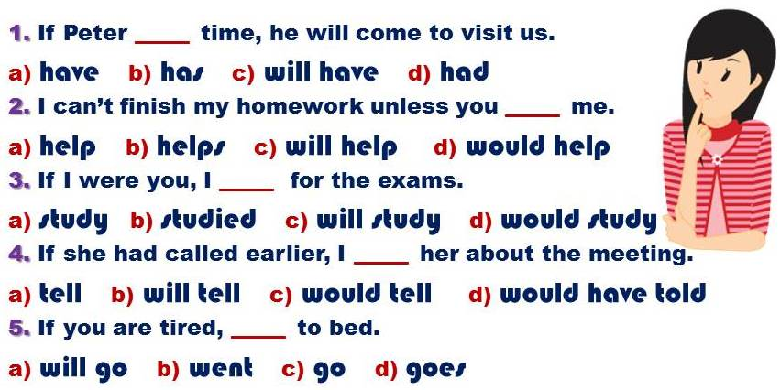
А) 1b, 2a, 3d, 4d, 5c Б) 1b, 2a, 3c, 4d, 5a
В) 1c, 2c, 3d, 4d, 5c Г) 1b, 2a, 3c, 4b, 5c

9. Fill in the gaps with the words from the box.
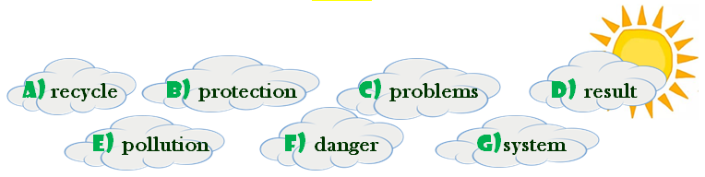
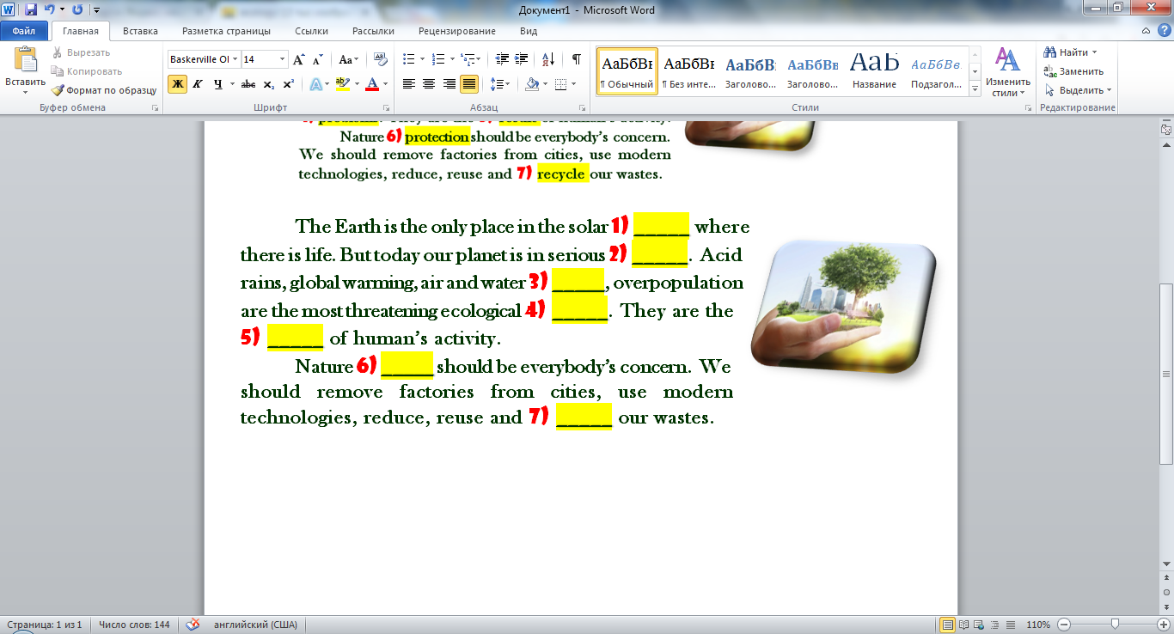
А) 1g, 2f, 3c, 4e, 5d, 6a, 7b Б) 1d, 2fe 3f, 4c, 5g, 6b, 7a
В) 1g, 2f, 3e, 4c, 5d, 6b, 7a Г) 1f, 2g, 3e, 4d, 5c, 6b, 7a

10. Look at the pictures and guess the words. Find out the key word.
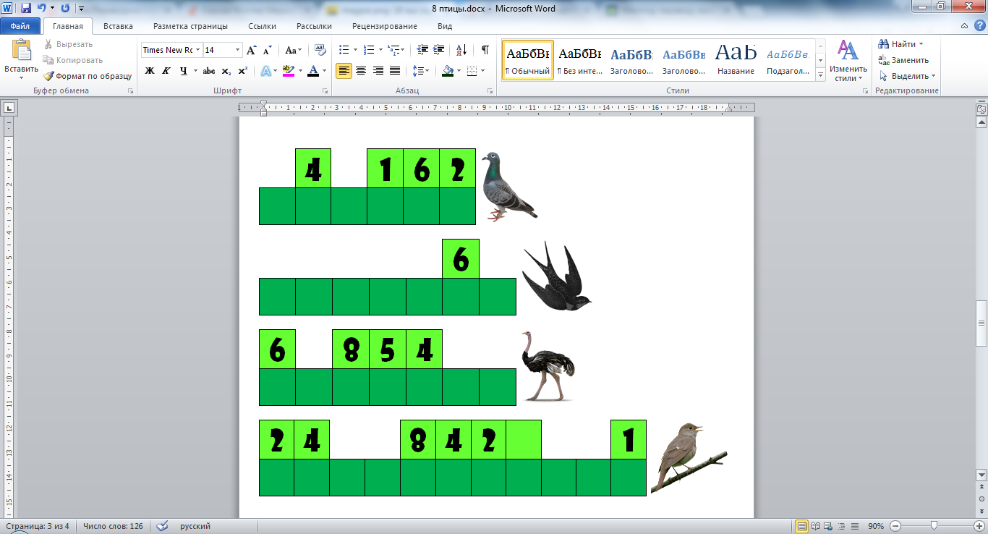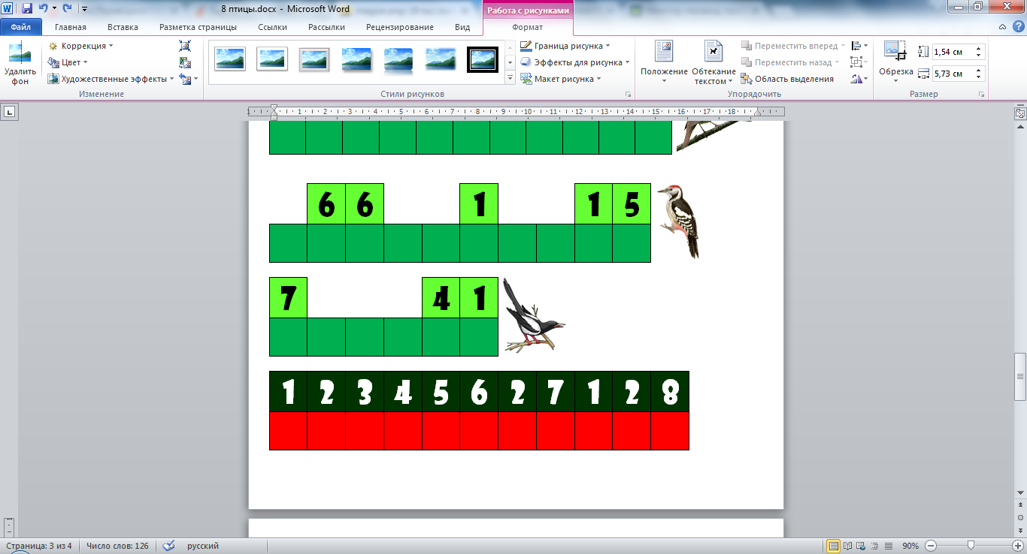
А) alternative Б) environment
В) celebration Г) certificate

