Олимпиада по английскому языку 9 класс

Рекомендуемое время выполнения заданий – 45 минут.

1. Find a mistake in one of the underlined fragments.
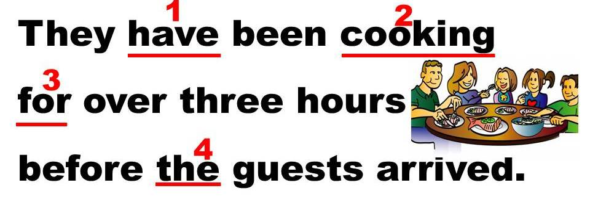
А) 1 Б) 2 В) 3 Г) 4

2. Make up a sentence from the given words.
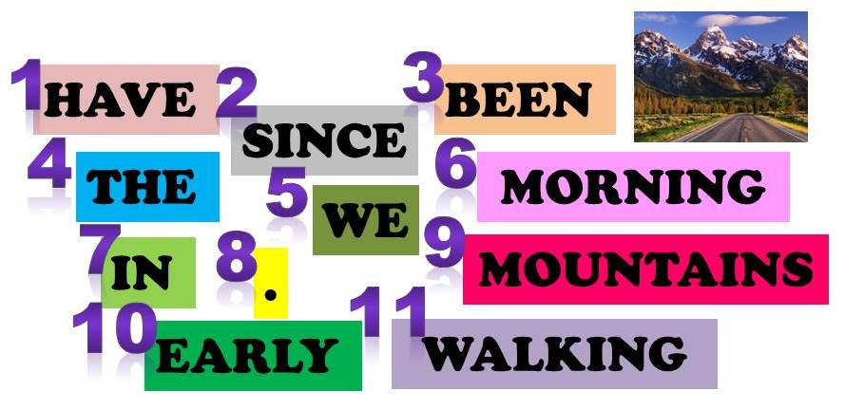
А) 5, 1, 3, 11, 7, 6, 9, 2, 10, 4, 8 Б) 5, 3, 1, 10, 7, 4, 9, 2, 11, 6, 8
В) 5, 1, 11, 3, 2, 4, 9, 7, 10, 6, 8 Г) 5, 1, 3, 11, 7, 4, 9, 2, 10, 6, 8

3. Match the following names of animals, birds and insects with their pictures.
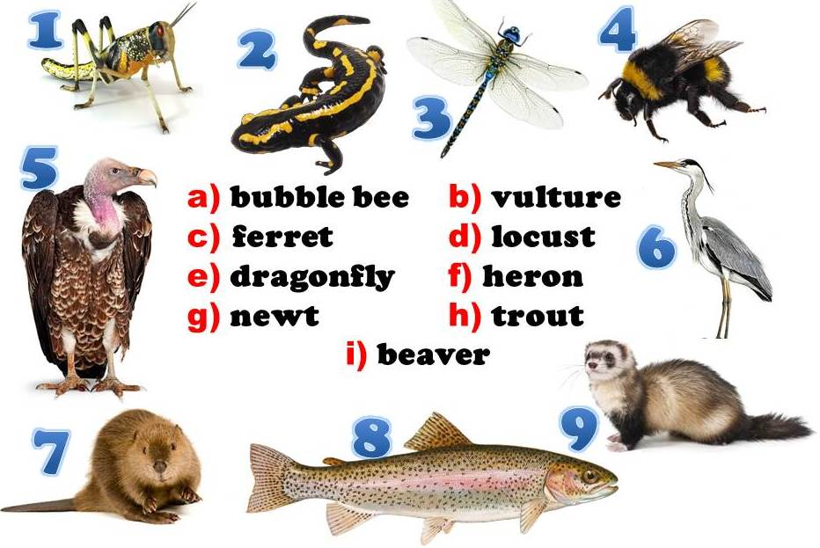
А) 1d, 2g, 3e, 4a, 5b, 6f, 7i, 8h, 9c Б) 1d, 2g, 3e, 4a, 5b, 6i, 7f, 8c, 9h
В) 1b, 2e, 3g, 4a, 5d, 6f, 7i, 8h, 9c Г) 1a, 2g, 3e, 4d, 5b, 6f, 7i, 8h, 9c

4. Form compound adjectives using the words below.
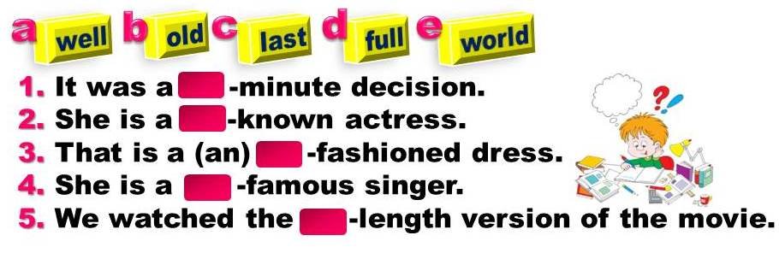
А) 1с, 2a, 3b, 4e, 5d Б) 1a, 2c, 3b, 4e, 5d
В) 1с, 2b, 3a, 4e, 5d Г) 1с, 2a, 3b, 4d, 5e

5. Fill in the gaps with the right postposition.
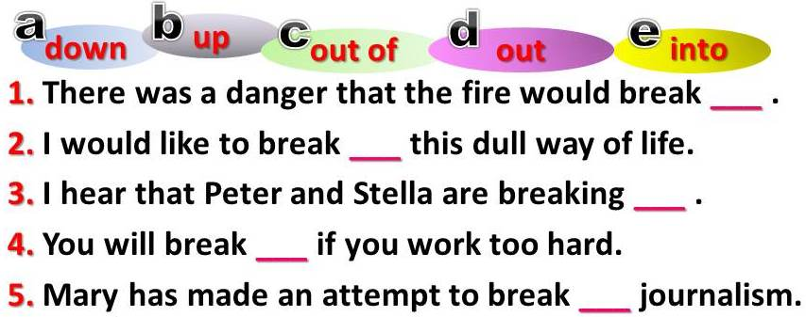
А) 1d, 2c, 3b, 4a, 5e Б) 1a, 2c, 3b, 4e, 5d
В) 1с, 2b, 3a, 4e, 5d Г) 1с, 2a, 3b, 4d, 5e

6. Choose the right variant.
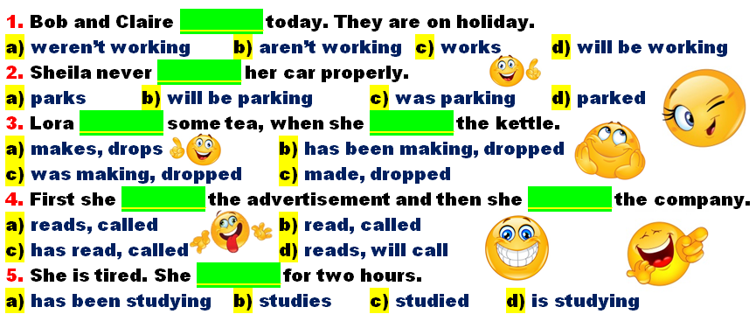
А) 1a, 2a, 3c, 4c, 5a Б) 1b, 2a, 3c, 4b, 5a
В) 1d, 2a, 3c, 4b, 5d Г) 1c, 2c, 3b, 4b, 5a

7. Choose the right option to complete the sentences.
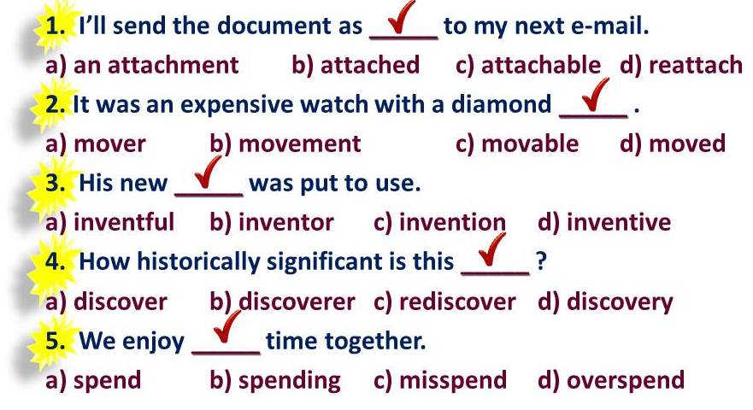
А) 1a, 2a, 3c, 4c, 5a Б) 1b, 2a, 3c, 4b, 5a
В) 1d, 2a, 3c, 4b, 5d Г) 1a, 2b, 3c, 4d, 5b

8. Fill in the gaps with the following words.
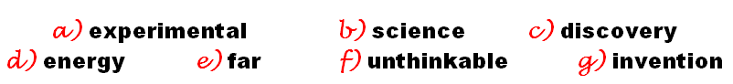
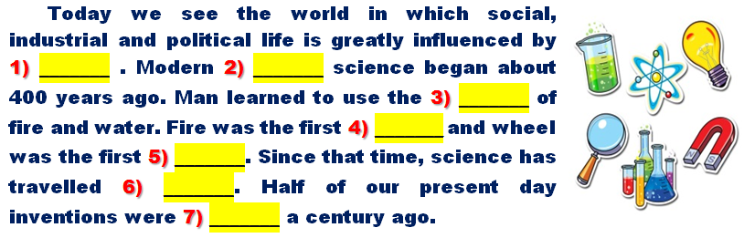
А) 1b, 2a, 3d, 4c, 5g, 6e, 7f Б) 1b, 2a, 3c, 4d, 5e, 6g, 7f
В) 1a, 2b, 3d, 4c, 5g, 6f, 7e Г) 1d, 2a, 3b, 4c, 5g, 6e, 7f

9. Solve the riddles.
1)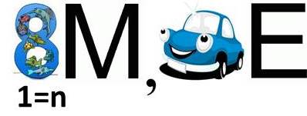
2) 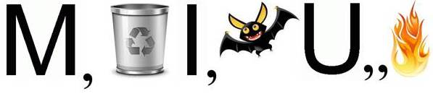
3)
А) 1 nightmare, 2 miniature, 3 coincidence
Б) 1 magnanimous, 2 miniature, 3 coincidence
В) 1 nightmare, 2 magnesium, 3 candescence
Г) 1 palmate, 2 machine-gun, 3 cannonade

10. Put in the jumbled words and find out the key word.
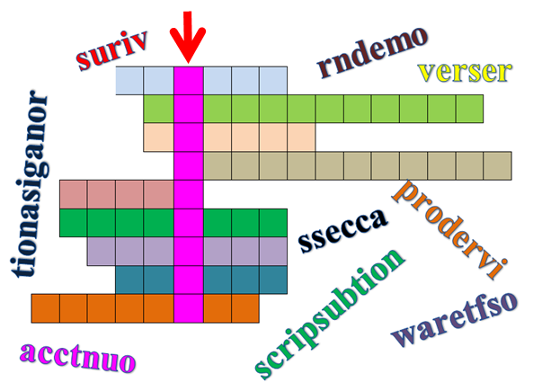
А) challenge Б) celebrate В) crossword Г) difficult

