Олимпиада по английскому языку 10 класс

Рекомендуемое время выполнения заданий – 45 минут.

1. Add the correct suffixes to the adjectives.
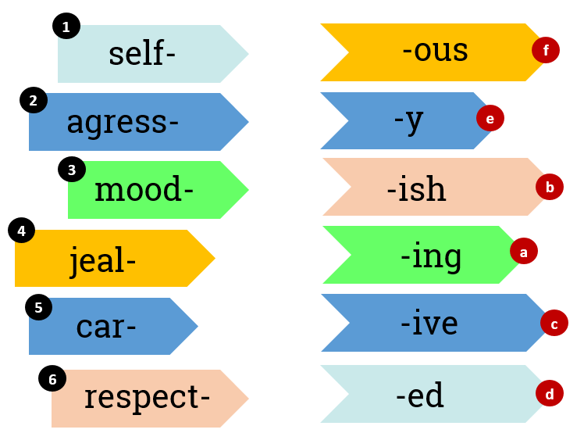
A) 1b, 2a, 3e, 4f, 5c, 6d Б) 1e, 2c, 3b, 4f, 5a, 6d
В) 1b, 2c, 3e, 4f, 5a, 6d Г) 1e, 2d, 3b, 4f, 5a, 6c

2. Find one odd word in each extract.
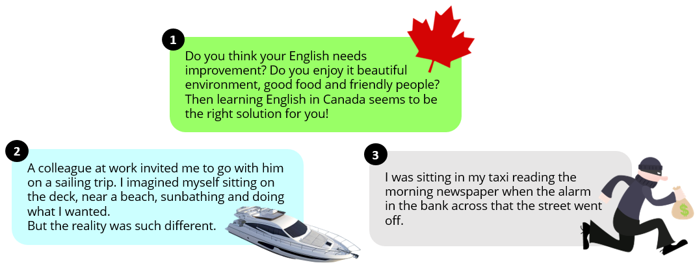
A) 1. it, 2. such, 3. that Б) 1. it, 2. such, 3. across
В) 1. seems, 2. what, 3. off Г) 1. be, 2. myself, 3. that

3. Match the parts of the letter with their names.
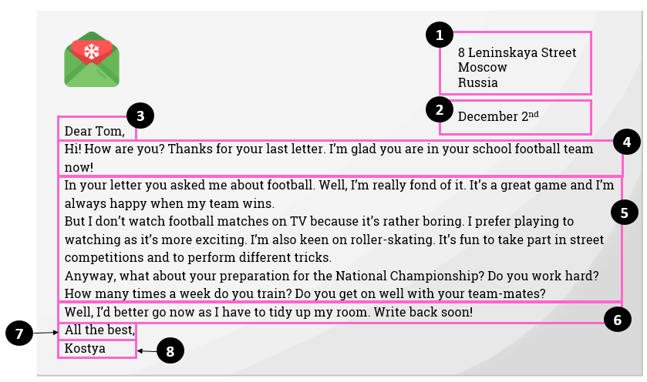
a) дата;
b) заключение / упоминание о дальнейших контактах;
c) подпись автора;
d) ссылка на предыдущие контакты, то есть благодарность за полученное письмо;
e) основная часть;
f) обращение;
g) завершающая фраза;
h) адрес.
A) 1h, 2a, 3c, 4d, 5e, 6b, 7g, 8f Б) 1h, 2a, 3f, 4d, 5e, 6b, 7g, 8c
В) 1h, 2a, 3c, 4d, 5e, 6g, 7b, 8f Г) 1h, 2a, 3f, 4b, 5e, 6d, 7g, 8c

4. Read the email and fill in the gaps with the correct prepositions.
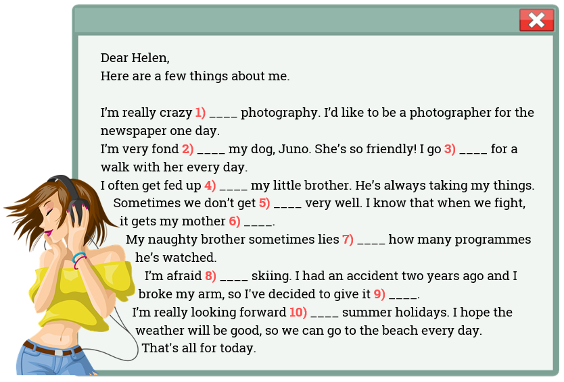
A) 1.with, 2.of, 3.out, 4.with, 5.up, 6.down, 7.about, 8.of, 9.off, 10.to
Б) 1.about, 2.of, 3.out, 4.with, 5.on, 6.up, 7.to, 8.of, 9.up, 10.to
В) 1.on, 2.of, 3.with, 4.with, 5.on, 6.down, 7.about, 8.of, 9.up, 10.on
Г) 1.about, 2.of, 3.out, 4.with, 5.on, 6.down, 7.about, 8.of, 9.up, 10.to

5. Read the extracts (1-5) and match them to a description (a-e).
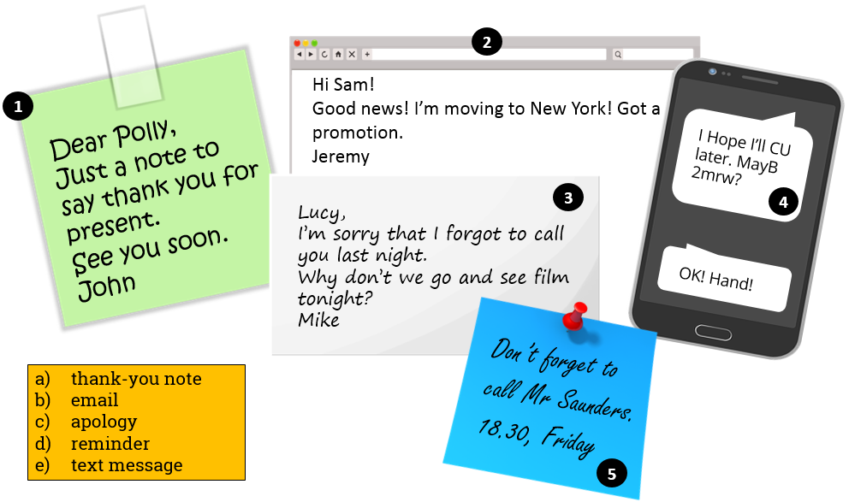
A) 1a, 2d, 3c, 4e, 5b Б) 1b, 2a, 3e, 4c, 5d
В) 1c, 2b, 3a, 4e, 5d Г) 1a, 2b, 3c, 4e, 5d
6. Match the parts of the sentences.
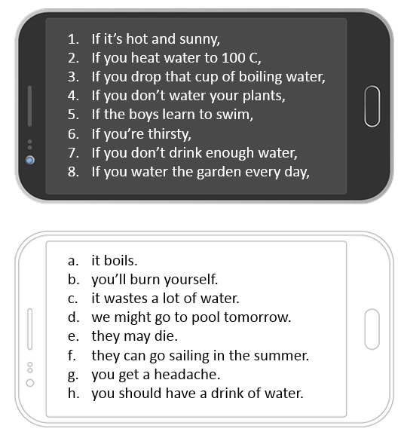
A) 1b, 2a, 3d, 4e, 5f, 6h, 7g, 8c Б) 1b, 2e, 3d, 4a, 5f, 6h, 7g, 8c
В) 1d, 2a, 3b, 4h, 5f, 6e, 7c, 8g Г) 1d, 2a, 3b, 4e, 5f, 6h, 7g, 8c

7. Match the descriptions to the people.
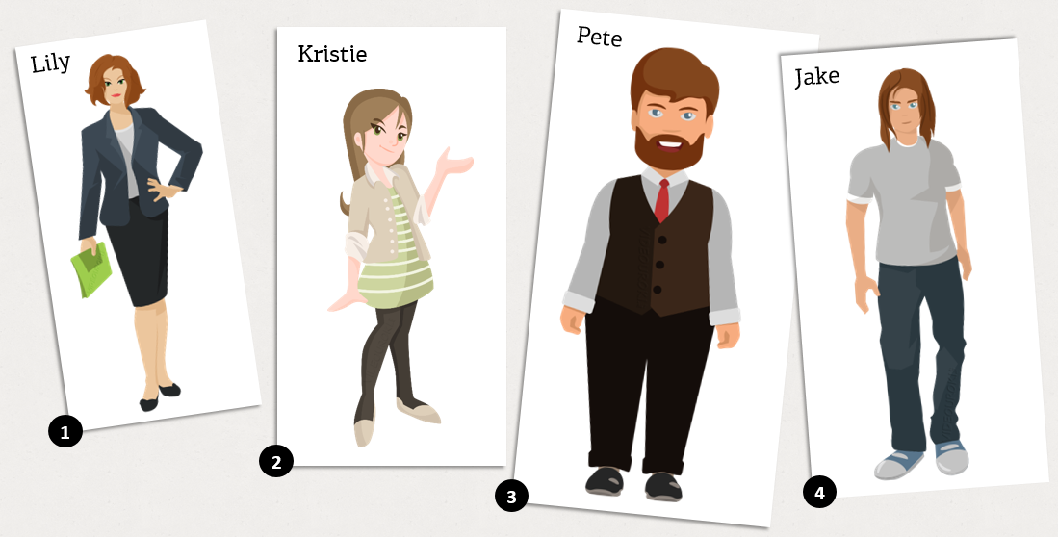
a) She is of medium height and slim. She’s got green eyes and nice long hair.
b) She’s attractive – she looks very friendly and happy. She’s got shoulder-length hair.
c) He’s got a nice moustache and a beard. He’s a bit overweight.
d) He’s tall and good-looking. He hasn’t got a beard.
A) 1b, 2a, 3c, 4d Б) 1a, 2b, 3c, 4d
В) 1b, 2a, 3d, 4c Г) 1d, 2a, 3c, 4b
8. Match the pictures with the words.
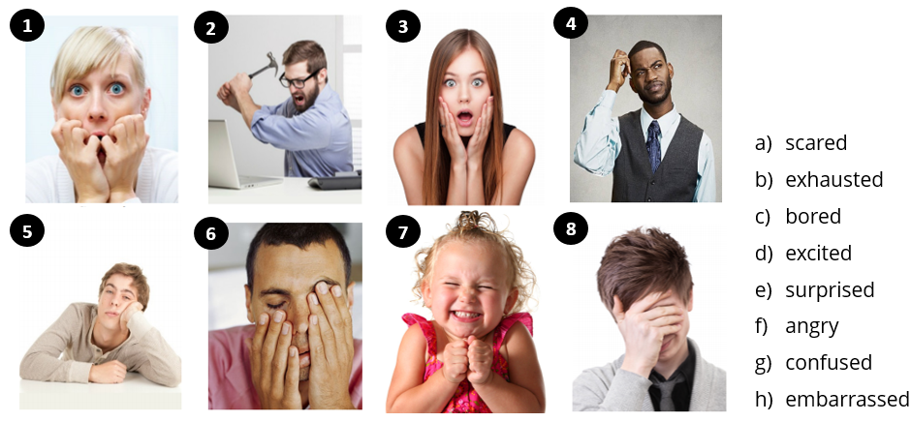
A) 1a, 2f, 3e, 4g, 5c, 6b, 7d, 8h Б) 1a, 2e, 3f, 4g, 5c, 6b, 7d, 8h
В) 1g, 2f, 3e, 4a, 5c, 6b, 7d, 8h Г) 1a, 2f, 3e, 4g, 5b, 6c, 7h, 8d

9. Choose the infinitive with/without TO or gerund.
1. I am looking forward to ___________ him.
a) seeing b) see c) seen
2. You should ___________ more.
a) reading b) read c) to read
3. You’d better ___________ home now.
a) going b) go c) to go
4. How about ___________ to the cinema tonight?
a) going b) go c) to go
5. Do you want me ____________ you a lift?
a) giving b) give c) to give
6. It’s no use ___________ to park here.
a) try b) trying c) to try
A) 1.c, 2.b, 3.a, 4.a, 5.c, 6.a Б) 1.a, 2.b, 3.b, 4.a, 5.c, 6.b
В) 1.b, 2.b, 3.b, 4.b, 5.b, 6.a Г) 1.c, 2.b, 3.a, 4.a, 5.a, 6.a

10. Choose the correct tense.
1. Mary is so organized! She __________ her History essay and I’ve only just started mine.
a) has already done b) already did c) had already been doing
2. She ______________ most of the work by the time her boss arrived.
a) finished b) has finished c) had finished
3. I ______________ basketball when I broke my leg.
a) was playing b) will play c) played
4) When he was young, he ___________ to like football.
a) got used b) is used c) used
5. I think I ________ Amy to help me with my Math homework.
a) will ask b) am going to ask c) ask
6. I ____________ lunch with Beth this time tomorrow.
a) will have b) will be having c) was having
7. She _____________ to Warsaw.
a) went b) has been gone c) has gone
8. I ____________ for you in the rain for two hours. Where have you been?
a) waited b) have been waiting c) was waiting
A) 1.a, 2.c, 3.a, 4.c, 5.a, 6.b, 7.c, 8.c Б) 1.b, 2.c, 3.a, 4.c, 5.c, 6.b, 7.c, 8.c
В) 1.b, 2.a, 3.a, 4.c, 5.a, 6.b, 7.c, 8.b Г) 1.a, 2.c, 3.a, 4.c, 5.a, 6.b, 7.c, 8.b

