Олимпиада по английскому языку 11 класс

Рекомендуемое время выполнения заданий – 45 минут.

1. Find the suffix that doesn’t belong to the part of speech in each column.
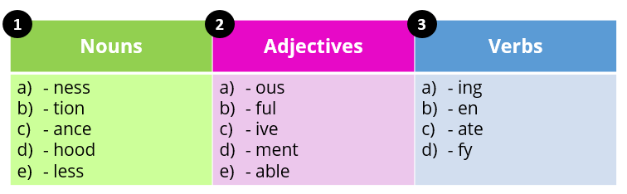
A) 1. e, 2.d, 3.a Б) 1. a, 2.d, 3.a
В) 1. e, 2.c, 3.b Г) 1. e, 2.d, 3.b

2. Choose the common term for the pictures below.

А) internet browser Б) website В) search engine Г) password

3. Find an odd word in each column.
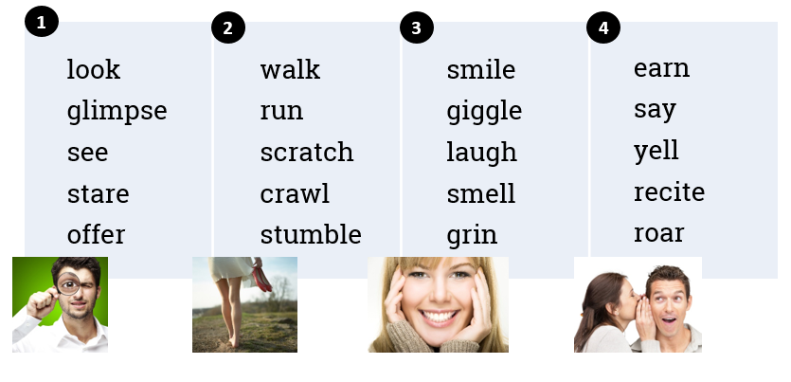
A) 1. offer, 2. scratch, 3. smell, 4. earn
Б) 1. glimpse, 2. scratch, 3. smell, 4. earn
В) 1. offer, 2. scratch, 3. smell, 4. yell
Г) 1. offer, 2. crawl, 3. smell, 4. earn
4. Fill in: a/an or the where necessary.
1. Anna was born in ____ Spain but now she lives in _____ Netherlands.
a) No article, the b) No article, no article c) The, no article
2. ____ Tower of London is _______ popular tourist attraction.
a) No article, the b) The, the c) The, a
3. The government promised to help _________ unemployed.
a) a b) the c) no article
4. ______ French language is spoken in _____ Canada.
a) A, no article b) The, no article c) The, the
5. It was late in ______ evening when Mr Smith returned home from ______ work.
a) the, no article b) the, the c) no article, no article
6. His mother went to _____ university to see him last month.
a) a b) the c) no article
A) 1a, 2c, 3b, 4a, 5c, 6c Б) 1b, 2c, 3c, 4b, 5a, 6b
В) 1a, 2b, 3b, 4b, 5c, 6a Г) 1a, 2c, 3b, 4b, 5a, 6b

5. Match the parts of the letter with their names.
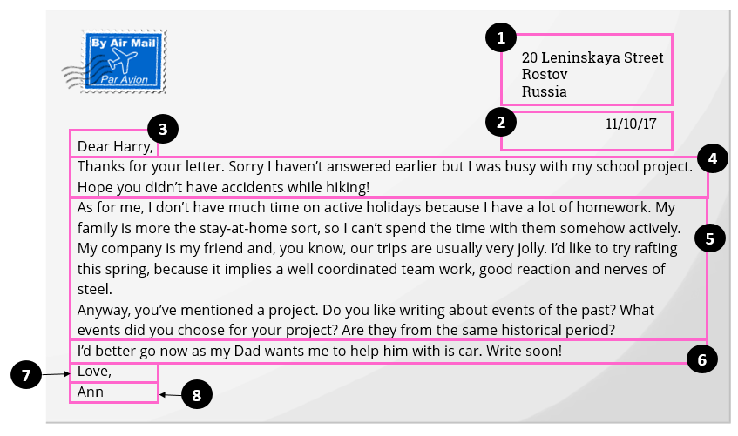
a) дата;
b) заключение / упоминание о дальнейших контактах;
c) подпись автора;
d) ссылка на предыдущие контакты, то есть благодарность за полученное письмо;
e) основная часть;
f) обращение;
g) завершающая фраза;
h) адрес.
A) 1h, 2a, 3c, 4d, 5e, 6b, 7g, 8f Б) 1h, 2a, 3f, 4d, 5e, 6b, 7g, 8c
В) 1h, 2a, 3c, 4d, 5e, 6g, 7b, 8f Г) 1h, 2a, 3f, 4b, 5e, 6d, 7g, 8c

6. Find one odd word in each extract.
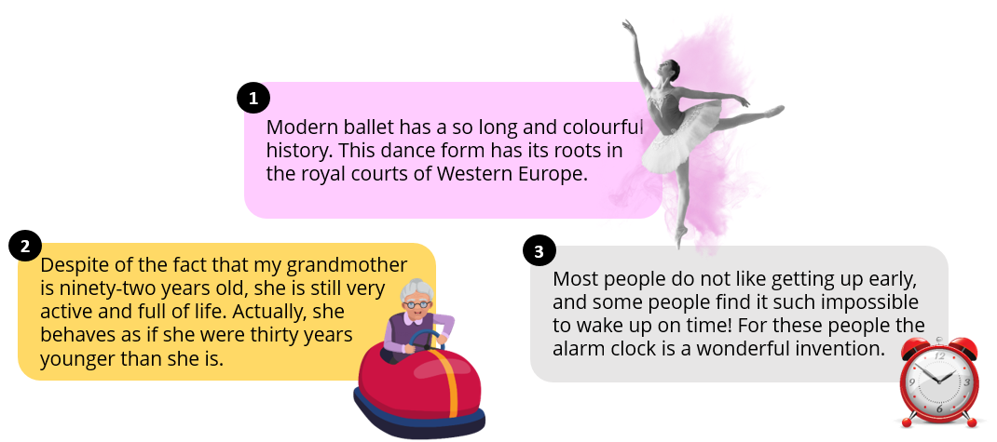
A) 1. a, 2. the, 3. such Б) 1. so, 2. of, 3. it
В) 1. so, 2. of, 3. such Г) 1. a, 2. of, 3. such

7. Find six words in the fillword describing personality. Use the clues. Make up a key-word from the remaining letters.
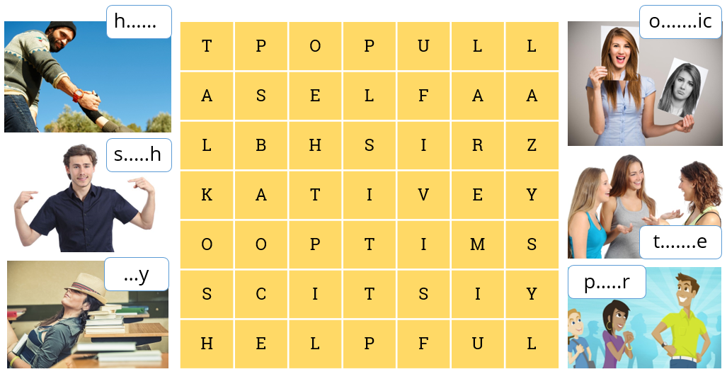
A) bossy Б) pussy В) bunny Г) moody
8. Choose the correct tense form.
1. It’s too hot ________ any sightseeing today.
a) to do b) doing c) do
2. I’m fed up with _________ in the house. Let’s go for a walk.
a) to sit b) sitting c) sit
3. I’d rather _________ at home. I’m a bit tired.
a) to stay b) staying c) stay
4. It’s not worth _________ a lot of money on sunglasses: you always lose them.
a) to spend b) spending c) spend
5. My dad won’t let me ____________ horror films.
a) to watch b) watching c) watch
6. They’ve decided __________ a dog for Sam’s birthday present.
a) to get b) getting c) get
7. Mrs Taylor would like __________ to you in her office at 9.30.
a) to talk b) talking c) talk
8. You should try __________ making so many spelling mistakes.
a) to avoid b) avoiding c) avoid
9. Peter’s promised _________ an article this week.
a) to write b) writing c) write
10. My mum’s tired of __________ me to tidy my room.
a) to tell b) telling c) tell
A) 1c, 2b, 3a, 4b, 5c, 6a, 7b, 8a, 9a, 10b
Б) 1a, 2b, 3c, 4a, 5c, 6a, 7a, 8b, 9a, 10a
В) 1a, 2b, 3c, 4b, 5c, 6a, 7a, 8a, 9a, 10b
Г) 1b, 2b, 3c, 4a, 5c, 6a, 7a, 8a, 9c, 10b

9. Find a mistake in one of the underlined fragments.
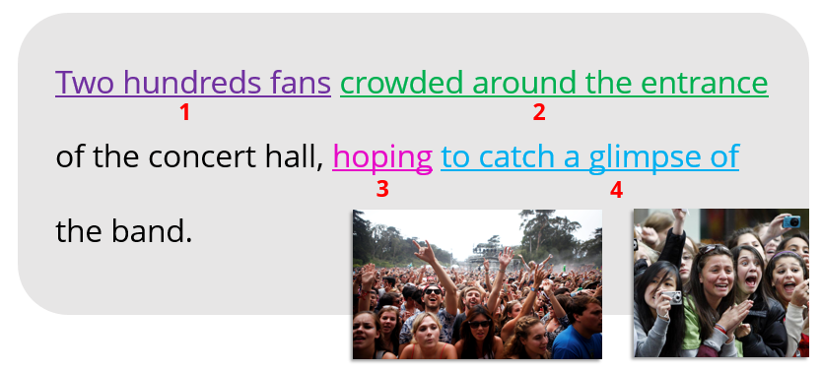
A) 1 Б) 2 В) 3 Г) 4

10. Rephrase the following sentences and choose the appropriate variant.
1. It’s forbidden to park here. a) You have to …
2. I allow you to use my phone. b) You should …
3. It’s necessary for you to go on a diet, like the doctor said. c) You mustn’t …
4. I advise you to consult the doctor. d) You may …
А) 1c, 2d, 3a, 4b Б) 1a, 2d, 3b, 4c
В) 1d, 2b, 3a, 4c Г) 1c, 2a, 3d, 4b

